**Monitoring Webserver with Data Dog**

Manideep([pmanideep@deloitte.com](mailto:pmanideep@deloitte.com))

1. Create an AWS EC2 Instance with any instance type.

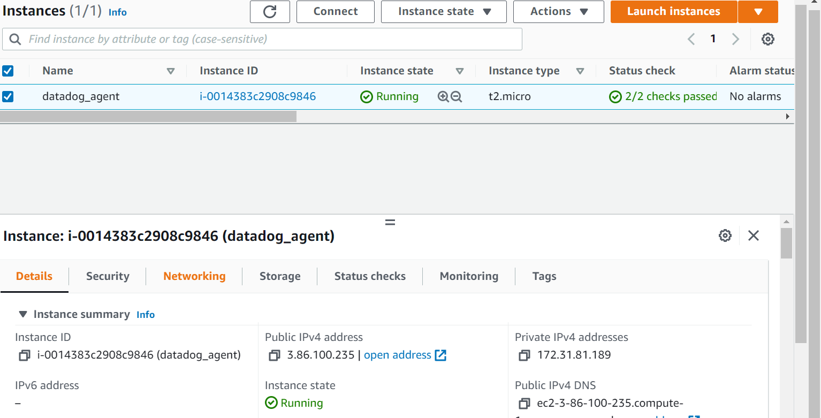

1. SSH into the Instance

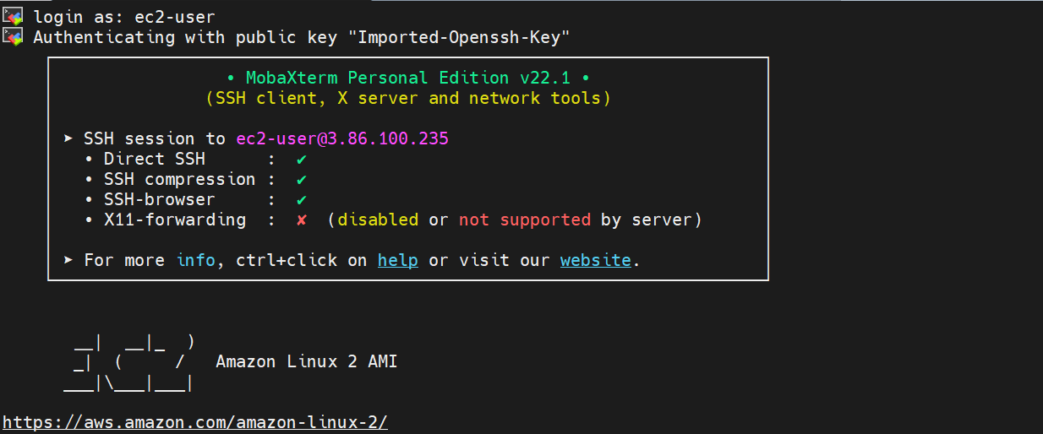

1. Install the Apache Webserver with the below commands
   * + sudo yum install -y httpd
     + sudo systemctl status httpd
     + sudo systemctl enable httpd
     + sudo systemctl start httpd



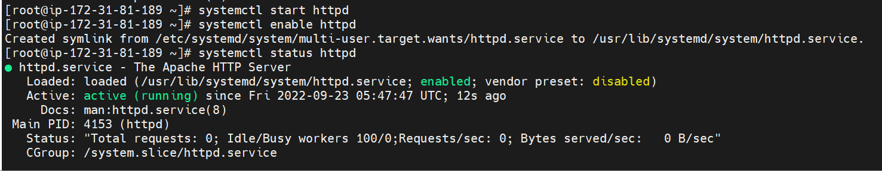

1. Open the Server on the browser

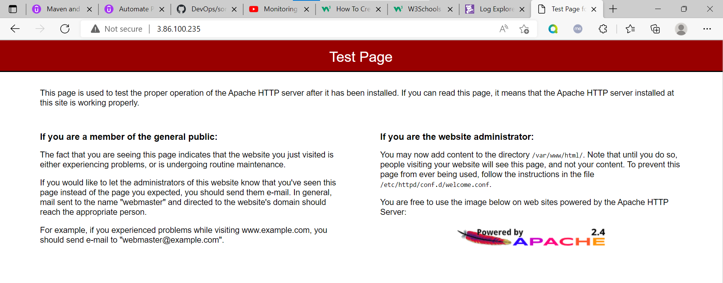

1. Login into the Data Dog Account and generate the API Key for the Integration with EC2 Instance

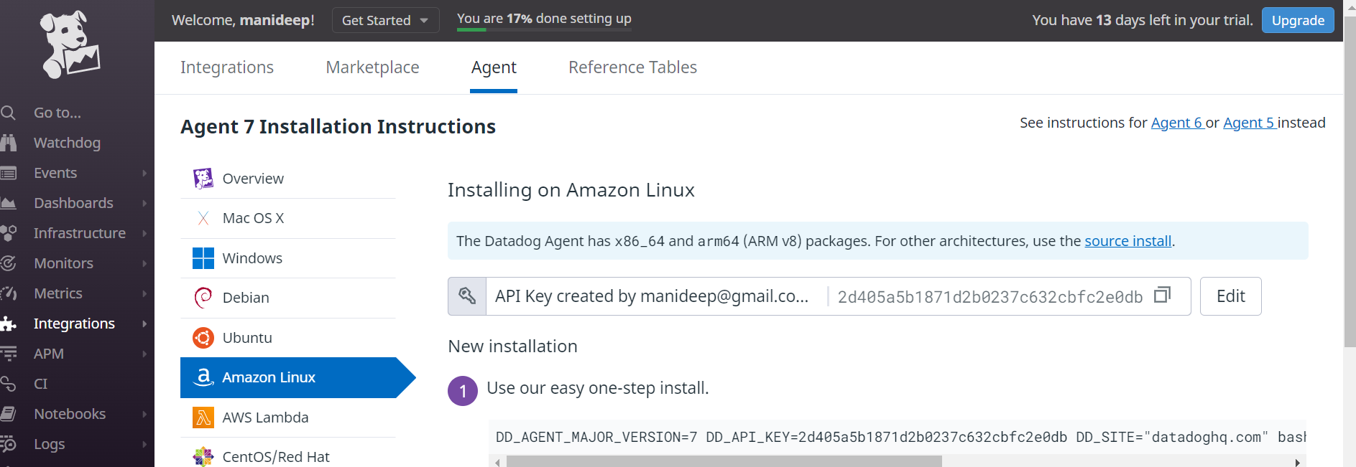

1. Run the Key on the EC2 Instance to install the Data Dog Agent

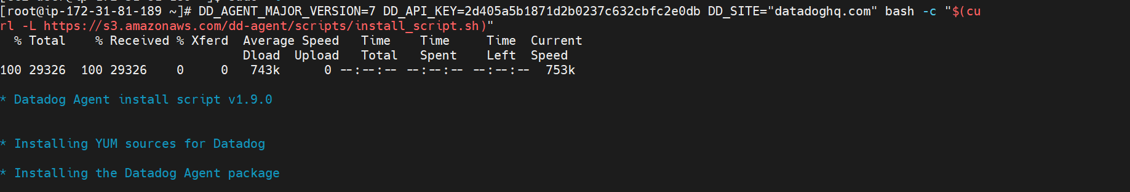

1. Check the Status of the Datadog Agent

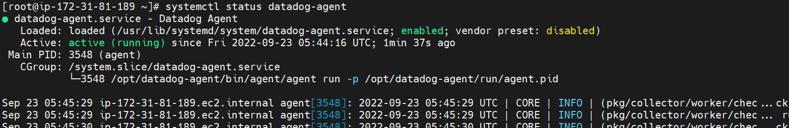

1. Configuring Apache for DataDog:

cp /etc/httpd/conf/httpd.conf /etc/httpd/conf/httpd_bu.conf

vi /etc/httpd/conf/httpd.conf à Add the location tag

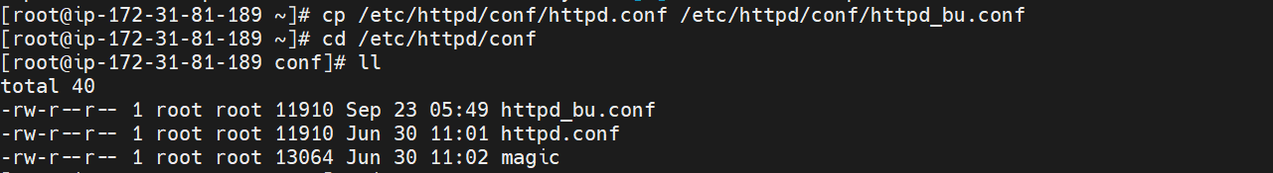

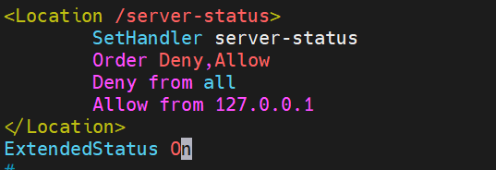

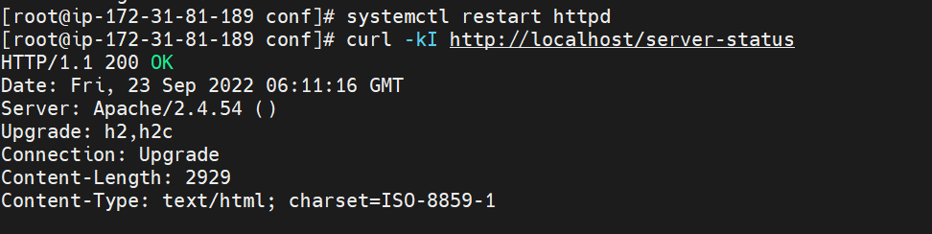

vi /etc/datadog-agent/conf.d/apache.d/conf.yaml

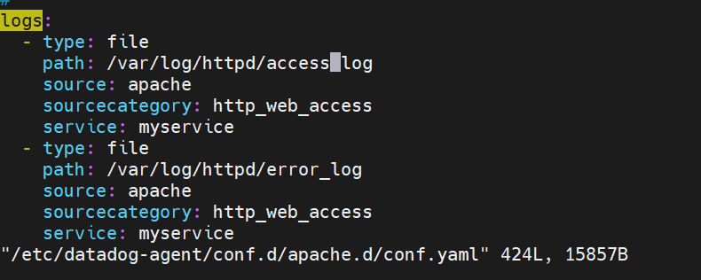

Restart DataDog-Agent:

sudo service datadog-agent restart

Check the DataDog Status:

sudo datadog-agent status

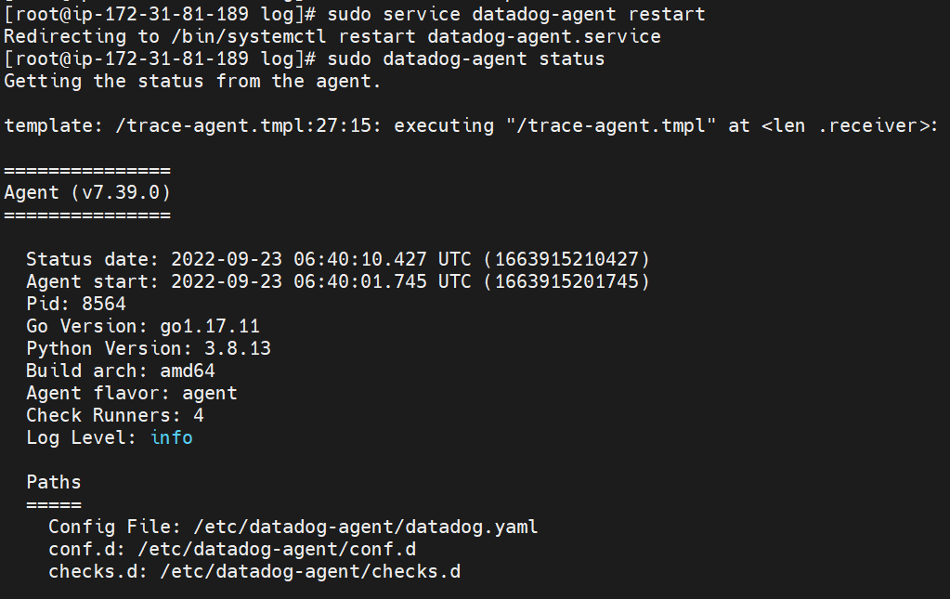

1. Open the Data Dog server



